**A role of receptor desensitization, feedback loops and spontaneous activity in astrocyte calcium responses.**

Astrocytes are a major cell type in the mammalian brain that produce large cytosolic calcium signals that are thought to mediate astrocytes’ critical functions in the brain. These calcium transients are often initiated by the binding of neurotransmitters (e.g., glutamate and ATP) to G-protein-coupled receptors (GPCRs) on the surface of astrocytes. In this work, we extend an earlier detailed model of the astrocyte calcium response [1,2] to include biochemical reaction cascades from the GPCR activation to the calcium signal. Importantly, we build in putative positive and negative feedback loops from the cytosolic calcium to the signaling molecule inositol 1,4,5-triphosphate (IP3), as well as two types of desensitization proposed for GPCRs (see Fig. 1 for a schematic of our model). We use dynamical systems analysis and numerical simulations of the model to test a number of experimentally-derived hypotheses about the astrocyte responses, and offer new testable predictions to further our understanding of this system.

Namely, we make the following observations and predictions. We start by providing computational evidence for two types of GPCR desensitization. Homologous desensitization affects only activated receptors, while the slower heterologous desensitization depends on a downstream intermediary molecule and affects all GPCRs. We propose experiments that would distinguish whether one or the other or both types of desensitization are at play in a particular experimental preparation. Then, we suggest that the experimentally-observed reduction in calcium level (or a reduction in amplitude of the continued calcium spike oscillations) in response to a sustained stimulus may be more dependent on GPCR desensitization than on depletion of calcium levels in the endoplasmic reticulum of the cell. Next, we show that astrocyte spontaneous calcium activity contributes to the variability of calcium responses to a brief agonist pulse. Finally, we demonstrate that potential positive and negative feedback loops from calcium onto IP3production play crucial roles in determining the response delay and the distribution of the calcium response types. Thus, we predict that the presence and the relative prominence of these feedback loops can be assessed based on experimentally recorded calcium responses to specific experimental perturbations.

Overall, our results improve our understanding of astrocyte physiology, and provide specific predictions for future experiments.

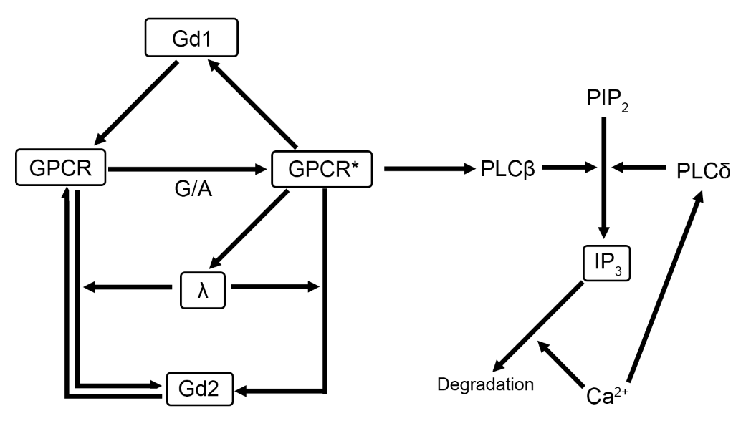

Figure 1. Schematic representation of our dynamical system. The GPCR system includes inactive GPCR (GPCR), activated GPCR (GPCR*) with activation induced by glutamate or ATP (G/A), homologous desensitization (Gd1), heterologous desensitization (Gd2), and an intermediary molecule representing the signal cascade that leads to heterologous desensitization (λ). The IP3 and calcium pathway includes phospholipase C (PLCβ which is activated by GPCR*, and PLCδ which is activated by cytosolic calcium), phosphatidylinositol 4,5-bisphosphate (PIP2), inositol 1,4,5-triphosphate (IP3), and calcium (Ca2+). The model includes both constitutive degradation of IP3, as well as degradation which is driven by cytosolic calcium.

**Acknowledgements**

This material is based upon work supported by the National Science Foundation under Grant No. NSF-DMS-1853673

**References**

1. Handy, Gregory, et al. **Mathematical investigation of IP 3-dependent calcium dynamics in astrocytes.** *Journal of computational neuroscience* 2017 42.3:257-273.

2. Taheri, Marsa, et al. **Diversity of evoked astrocyte Ca2+ dynamics quantified through experimental measurements and mathematical modeling.** *Frontiers in systems neuroscience* 2017, 11:79.